Trade Application

Christmas Present showjumping
  - Saturday 10th December 2022
Westmoor Farm Equestrian Centre,Longhorsley,Nr Morpeth,NE65 8QX
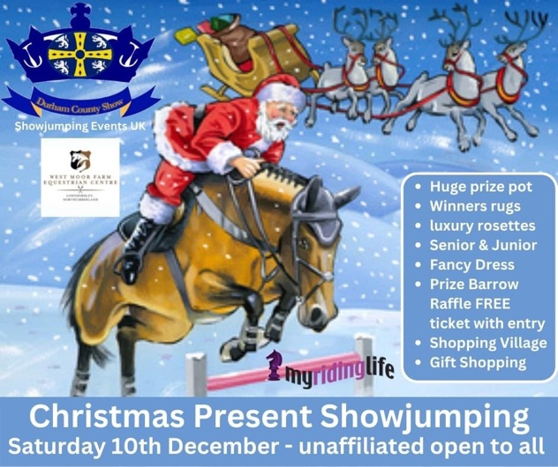
Business Name……………………………………………………………………………………………
Address…………………………………………………………………………………………………….
Tel No………………………………………………………………………………………………………
Goods you sell…………………………………………………………………………………………
As part of our commitment to support local businesses all pitches are FREE. Traders are required to donate a prize to be given out at the show. Tell us what you’re donating as a prize…………………………………………………………………………………………………………….
Traders are required to carry their own PL insurance min 2M a copy of which should Be kept with you whilst attending our shows/events.
SET UP-BREAKDOWN INSTRUCTIONS
Traders must bring their own table and chairs. Pitches one table frontage. (Please ask if you need more space)
Set up begins at 8am and must be completed by 9am (show opens 9am) set down is on closure of show estimated to be 4-5pm.
Prize donations – please take yours to the judges table on arrival
Only trade your approved goods, this is to avoid duplicate goods and dilution of trade.
Return your completed forms by email to durhamcountyshow@outlook.com

