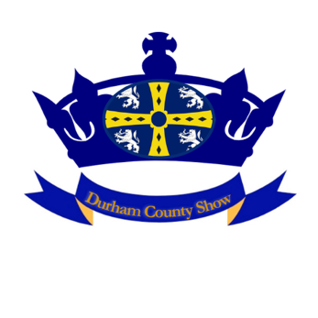

Conditions of entry to our events – Riders/Horse Show Exhibitors

Who We Are

Durham County Show Ltd Company No 12164390 Private Limited Company
Registered Office
Armstrong Campbell Llp, Regent Centre, Gosforth, NE3 3PF.

Conditions of Entry
All riders and exhibitors enter at their own risk.
All riders and exhibitors must carry their own insurance for all risks relating to themselves and their horses/animals.
All riders and exhibitors must carry insurance cover for all risks relating to risks caused to others and their property.
All riders and exhibitors must carry insurance to cover damage to our venues that may be caused by themselves or their animals.
All riders and exhibitors accept that it is a condition of entry that they accept that Durham County Show Ltd is in no way responsible for any injury to exhibitors/animals/property that is sustained as a result of competing/entering/exhibiting. No claims can be made against Durham County Show or its insurers for any loss sustained.

Horse Passports/Animal Document’s
Must have all necessary document’s necessary to compete. All vaccination’s must be current. Passports must be available to check if requested by officials.

Dress Code
Safety hats/helmets must be current standard and spot checks will be carried out.
Correct dress according to code must be worn at all times to include footwear.

Biosecurity
Please read our document’s

These are the important terms that apply to all of our exhibitors. Each event may have additional terms it is your responsibility to ensure that you follow all terms and conditions for Durham County Show Ltd and any additional venue terms.

